**Md.**

**S**

**afiatul islam**

**khan**

Student

**safiatul15**

**-**

**14448**

**@diu.edu.bd**

**01533062988**

**Uttara**

**,**

**Dhaka 1230**

**Skills**

**C++.Java.**

**Python.**

**HTML.**

**CSS.**

**Micr**

**osoft office**

**Field of Interest**

**Netw**

**ork**

**and Web**

**development**

**.**

[**I**](https://samulit.com/.I)

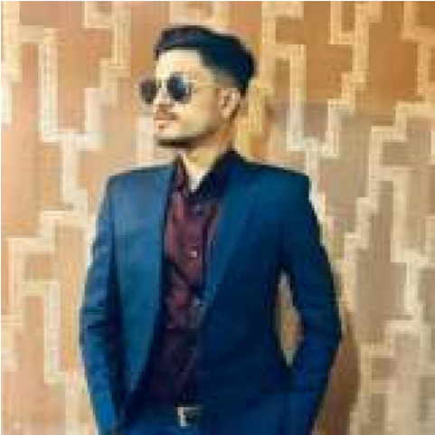

**Objective**

I am Safiatul islam khan. I am coming from Daffodil international university In CSE.I am working to SamulIT at web developer.

https://samulit.com/

https://www.linkedin.com/in/safiatul-islamkhan-saif7349381b2 /

**Academic Details**

**Daffodil international university**

Computer science Engineering CGPA 3.75,

SSC GPA 5.00 HSC 5.00

**Work Experience**

**1 .working to SamiulIT at web designer.**

Marketing officer, My style international limited. , Nov 2020 - till date

**Project Details**

**Saif.com** Business side

**Industrial Exposure**

**Industrial Visit at:** SamullIT, My style international limited. [https://samulit.com/](https://samulit.com/.I)

**Training at:** 2 month training for web developer.

**Achievements:** Won competition, volunteering, Professional working to IT company.

# Curricular Activities

**Co-Curricular**



Sports, programming, Dance, Music, Debate  **Md.safiatul islam khan** **Extra-Curricular** Web developer.

# Strength



Programming basic clear.

**Hobbies** Writing and reading**.**